Curriculum Vitae
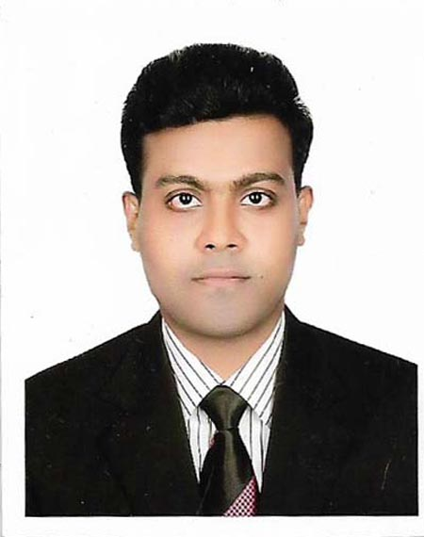

JAHIDUL ISLAM
Village : kalikapur, Post: Gunti,
Thana: Ishwardi, District: Pabna.
Mobile : +8801746-101549
+8801738-632322
e-mail : jahidina1@gmail.com

Career Objective:

Seeking a professional working environment that offers development opportunity for a brighter career in challenging profession where honesty, efficiency and hard Work are required. To be part of a organization which committed to the society and nation, believes in the growth of employees and strives to excel in its field work where I can utilize my knowledge, technical skills and creativity. I will try my level best to use both my potentiality and efficiency for the development of the Bank as well as Bangladesh.

Scholastic Track Record:

Masters of Arts (M.A) 2013
Subject : Bangali.
Institution : Govt.Edward college Pabna.
Division : Second Class, Marks : 58%
Duration : 1Year

Bachelor of Arts (B.A) 2012

Subject : Bangali.
Institution : Govt.Edward college Pabna.
Division : Second Class, Marks : 55%
Duration : 4 Years

Higher Secondary Certificate (Alim) 2007

Concentration/Major : Humanity.
Institution : Dasuria madinarul-ulm-alim madrasah.
GPA :3.25 (out of 5 )
Duration : 2 Years
Secondary School Certificate (Dhakil) 2005

Concentration/Major : Humanity.
Institution : Sampur Al-Hera Dhakil Madrasha.
GPA :3.75 (out of 5 )

Bachelor of Physical Education(BPED)-2019

Concentration/Major: Physical training.
Institution : Pakshi college of Physical Education,Pabna.
CGPA :3.00 (out of 4.00 )

Computer Literacy:

- I have completed the courses of MS Word, Excel, PowerPoint, Access and Internet operations from a reputed organization.

Personal Information:

Full Name : Jahidul |Islam
Father’s Name : Siraz Ali
Mother’s Name : Most. Hajera Begum
Date of Birth : March 01, 1991
Marital Status : Unmarried
Religion : Islam
Nationality : Bangladeshi (By Birth)
National ID No : 3253599306
Present Address : Village: Kalika pur, Post: Gunti
Thana: Ishwardi, District: Pabna.
Permanent Address :Village: Kalika pur, Post: Gunti
:Thana: Ishwardi, District: Pabna.

Language Proficiency:

- Bangla : I have excellent reading, writing & speaking skill.
- English : Excellent in reading, writing & good in speaking.

Employment History:
 |  | Actor ( january 1, 2011- December-2019)
BRAC :
Branch Location : Dashuria, Ishwardi, Pabna .
Department: Empowerment communication programme .
Duties/Responsibilities:
1. Prevent Early marrage.
2. Prevent Acid throgh.
3. theater.
2. |  | Asst: teacher ( January 1, 2017 – Till Now)
Islamic Foundation:
Branch Location : Ishwardi,Pabna.
Duties/Responsibilities:
1. Teaching(Al Quran).

TRAINING INFORMATION:
Training Title | Topic | Institute | Country | Location | Year | Duration
Actor | theater | Brac BLC | Bangladesh | Dhaka BLC | 2015 | 10 days

REFERENCE
Abdus Sattar  Lecturer  M.Munsur Ali College Pabna.  Pabna Meril Road ,Pabna.  Mobile: +8801741- 859875 | Md. Sagor hosan  Lecturer  Samsul Huda Hnors College Pabna.  Tabunia ,Pabna Sador pabna.  Mobile: +8801719-132540

I hereby declare that all the information is provided above is true & correct .If you want I can prove it.

___________________
Jahidul Islam

